Compendium of Good Practices
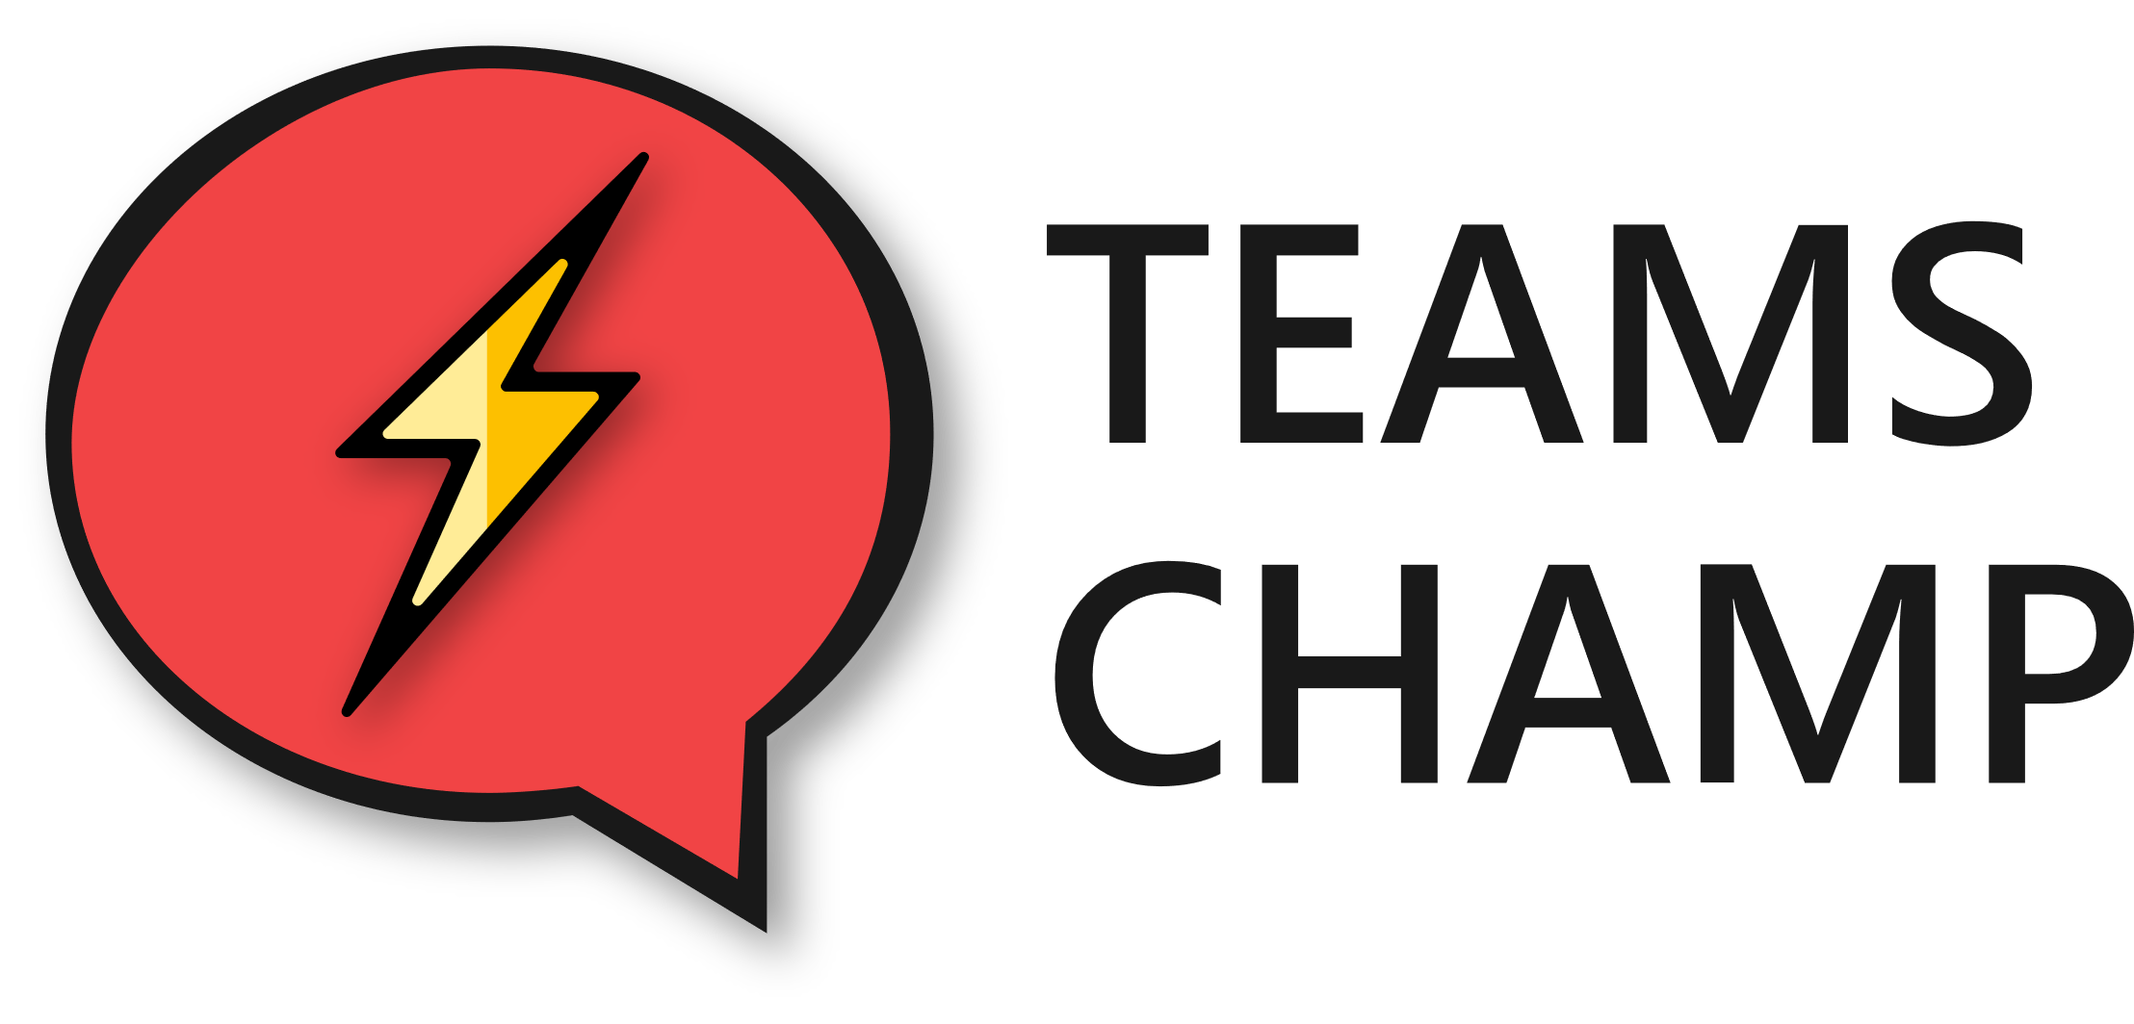
to Earn Points With

- "Where There’s Smoke, There’s Fire" 🔥

Check out the Microsoft Teams channels that interest you the most. If the name of the channel is in bold, it's because there are new comments on the chat room that might interest you. You can also add/remove computers and channels from favorites to prioritize how you want to view information.

- "Two Heads Are Better Than One" 👫

How many times have you crossed e-mails with several other colleagues in copy? Sure it would be better to discuss it all together in a group chat in Teams, why don't you try creating one yourself?

- "You Learn Something New Every Day" 🎓

Save 10 minutes each day to check out what's new on your Chatter network. It will help you disconnect and you'll find for sure some very interesting posts from your colleagues. You can like their posts to show them your support!

- "When in Rome, Do as the Romans Do" 👍

And since you're on Yammer... Why don't you share something interesting you just discovered today? Your colleagues will be grateful and a healthy debate will undoubtedly take place.

- "Seek and Ye Shall Find" 🕵

I'm sure there are many Yammer groups that you still don't know about or that perhaps didn't interest you when they were created, but now they do. Check out the groups from time to time or even create a new one if you don't find the one you are looking for!

- "Two Heads Are Better Than One" 📚 👫

Have you finished a document and want your colleagues to review it? Wouldn't it be better to just share it with them rather than having to attach it to an email? Leave it somewhere, on Teams or SharePoint, that everyone has access to or keep it on your OneDrive, and attach the link to an email. This will keep you from having to piece together all the changes later!

- "Don't Be a Dog in the Manger" 🐕

Remember that you can synchronize SharePoint libraries (and therefore the "Files" tab of a Teams channel), so you can work with your documents without opening a browser. However, try to synchronize only what's essential, what you work with on a daily basis. And if you ever need to, you can also stop synchronizing the folders you want.

- "Desperate Times Call for Desperate Measures" 📊

If you lost your computer right now, would you lose all your documents? To avoid losing all the documents you work with on a daily basis, you should keep them in the cloud. This means storing all your information (what was once "My Documents") on your OneDrive and all the information shared with your colleagues on Teams or SharePoint.

- “The King Is Dead, Long Live the King!” 👑

If you ever need to hold a meeting but not everyone will be able to attend in person, you can create a new online meeting: from Outlook with a link to a meeting room, either in Teams (preferably) or Skype.

- "Each to His Own and Office 365 Watching Over Everyone" 📲

In addition to all the computer and web access applications we have for all of these Office 365 services, we also have app versions for mobiles and tablets! Access your device's app store to download Outlook, Teams, Yammer, OneDrive, SharePoint, Word, Excel, PowerPoint, OneNote, Planner, To-Do.…

